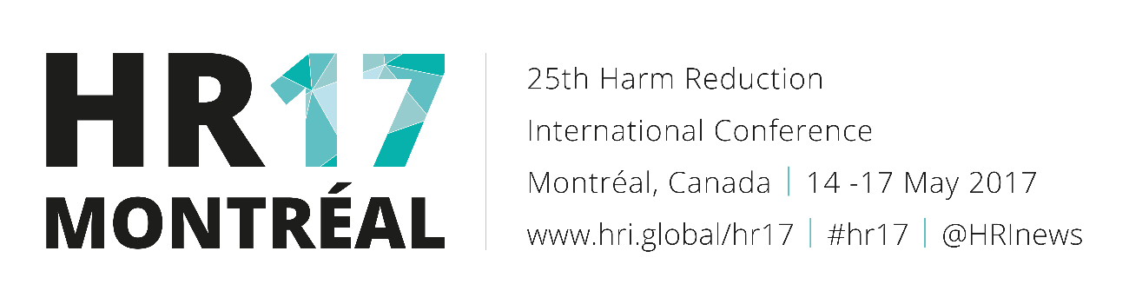
Evaluation of a fentanyl drug checking program for clients of a supervised injection site, Vancouver, Canada (Oral abstract 188)
Issue: Vancouver is experiencing a public health emergency related to opioid overdoses driven in part by consumption of street drugs contaminated with illicitly manufactured fentanyl. We tested a novel harm reduction intervention in which clients of a supervised injection service were offered the opportunity to check their drugs for fentanyl.
Setting: Insite is a facility offering supervised injection services in Vancouver’s Downtown East Side, a community with persistent high levels of individual and societal harms from injection drug use, including overdose deaths.
Project: Clients of Insite were offered an opportunity to check a sample of their drugs for fentanyl using a test strip designed to test urine for fentanyl. Results of the drug check were recorded by Insite staff along with the substance checked, whether the client disposed of the drug or reduced the dose, experienced an overdose, or required treatment with naloxone. Qualitative interviews with individuals who did and did not access the drug checking service are being conducted.
Outcomes: From July 2016 to March 2017, clients performed 1099 fentanyl drug checks with 37.9% of checks performed pre-consumption and 62.1% performed post-consumption. Heroin, crystal meth and cocaine were the client-reported substances most commonly being checked representing 79.6%, 7.2% and 5.3% of all checks performed. Client only reported checking fentanyl 0.2% of the time. Overall, 79.1% of drugs checked were positive for fentanyl (83.4% for heroin samples, 81.5% for crystal meth samples and 40.3% for cocaine samples). Considering only pre-consumption checks, a positive result was associated with higher odds of dose reduction (OR 10.8 (4.25-27.4), p<0.00001) but not drug disposal (OR 1.25 (0.57-2.72), p=0.57). When stratified by substance checked, this association remained significant for clients checking heroin (OR 13.76 (3.23-58.10), p<0.00001) but not crystal meth or cocaine. Considering all drug checks, a positive result was associated with higher odds of overdose (OR 6.09 (2.45-15.15), p<0.0001) and naloxone administration (OR 4.45 (1.78-11.13), p<0.001). However when stratified for timing of drug check, these associations remained significant only for post-consumption checks. This indicates a potential bias that could result from clients or staff performing drug checks following an overdose. However, this could also result from a reduced risk of overdose in clients who reduce their dose. And indeed, dose reduction was associated with lower odds of overdose (OR 0.26 (0.09-0.72), p<0.004) and naloxone administration (OR 0.26 (0.08-0.84), p<0.012). Preliminary results from the qualitative evaluation indicate the program limits overdose risks by helping clients to identify drugs contaminated with fentanyl, and thus exercise greater caution when injecting. Additionally, clients involved in drug selling reported using the program to identify drugs contaminated with fentanyl in order to warn drug buyers and avoid selling to inexperienced users.
Conclusions: Offering fentanyl drug checking at Insite encouraged clients to adopt the harm reduction practice of dose reduction and decrease their risk of overdose. Vancouver Coastal Health plans to continue offering drug checking at Insite with a greater emphasis on pre-consumption checks, complete the qualitative evaluation and investigate the possibility of introducing fentanyl drug checking in other settings.

- Type: Oral, Track: Drug checking: from dance clubs to the dark web
- Presenting author: M. Lysyshyn
- Location: Cartier I

