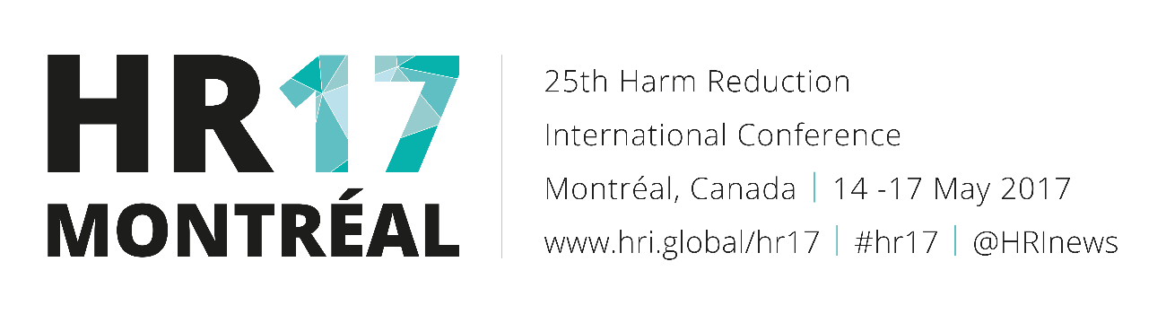
"Overamping" - An Understudied Overdose Experience among People Who Inject Drugs (Oral abstract 518)
Background: In recent years there has been substantial focus on opioid overdose. Significantly less attention has been paid to “overamping,” a cluster of symptoms resulting from stimulant use. We estimated the prevalence of overamping among people who inject drugs (PWID) and characterized symptoms.
Methodology: We recruited PWID in Fresno, California, using respondent driven sampling. Eligibility criteria were >=18 years old and injected in the past 30 days. An interviewer-administered survey included demographics, drug use history, and overdose experiences.
Results: We surveyed 494 PWID; median age was 46 years (IQR: 33-54), 38% were female, and most identified as White (43%) or Hispanic/Latino (39%). Median years since first injection was 22 years (IQR: 7-35) . Thirty-nine percent had overamped on stimulants (median 3 times); 27% of those who overamped did so in the past three months. Drugs taken on the day of the last event included methamphetamine (73%), heroin (41%), and/or cocaine/crack (20%). Symptoms included fast heart rate (86%), high body temperature/overheating (76%), irregular breathing (71%), extreme anxiety (72%), panic (68%), hypervigilance (67%), extreme agitation (64%), extreme paranoia (51%), passing out (46%), chest pain/tightening (44%), nausea/vomiting (43%), hallucinations (40%), feeling paralyzed but awake (26%), seizure (17%), and jerking or rigid limbs (34%). A majority (73%) said someone else was present at the last event; however a minority were attended by an ambulance (18%) and/or were treated at a hospital (25%).
Conclusion: More than one in three PWID in our sample overamped on stimulants, and most said someone else was present. Harm reduction programs where stimulant use is common should consider expanding overdose education efforts to include overamping risk reduction, identification, and response. Many PWID in our study reported both stimulant and heroin use on the day of their last overamping event, suggesting that combining education on opioid and stimulant overdose may be appropriate.
- Type: Oral, Track: Overdose in North America: Policy and practice
- Presenting author: R. Pollini
- Location: Cartier I & II

