61 Mansell Street Head Office: (+44) 207 324 3535
London Conference Team: (+44) 151 702 0630
E1 8AN Email: conference@hri.global
U.K. Web: www.hri.global

Nomination Form for the International Rolleston Award 2019

Nominee: Individual, group or organisation
Individual
First name: | Last name: | Country:
Organisation:
Position:
Contact email:
Group
Name of the group:
Year established: | Contact person:
Address:
City: | Country: | Postcode:
Contact email: |  | Website:
Organisation
Name of the organisation:
Organisation type:
Year established: | Contact person:
Address:
City: | Country: | Postcode:
Contact email: |  | Website:
Nominator
First name: | Last name:
Position:
Organisation:
Address:
City: | Country: | Postcode:
Contact email: |  | Website:
How long have you known the nominee?

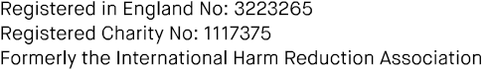

Nominator’s signature Date

This nomination form should be sent to awards@hri.global, and must be received by Monday 31 December
2018.

You should include this form, a short biography of the person or description of the group/organisation, and a statement explaining why the nominee should be considered for this award (maximum three pages in total, in free format), and a letter of support from individuals or organisations familiar with the nominee’s contribution (optional, but strongly encouraged).

