61 Mansell Street Head Office: (+44) 207 324 3535
London Conference Team: (+44) 151 702 0630
E1 8AN Email: conference@hri.global
U.K. Web: www.hri.global

Nomination Form for the National Rolleston Award 2019

Nominee: Individual, group or organisation (maximum one per nominator)
Individual
First name: | Last name: | Country:
Organisation:
Position:
Contact email:
Group
Name of the group:
Year established: | Contact person:
Address:
City: | Country: | Postcode:
Contact email: |  | Website:
Organisation
Name of the organisation:
Organisation type:
Year established: | Contact person:
Address:
City: | Country: | Postcode:
Contact email: |  | Website:
Nominator
First name: | Last name:
Position:
Organisation:
Address:
City: | Country: | Postcode:
Contact email: |  | Website:
How long have you known the nominee?

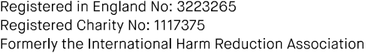

Nominator’s signature Date

This nomination form should be sent to awards@hri.global, and must be received by Monday 31 December
2018.

You should include this form, a short biography of the person or description of the group/organisation, and a statement explaining why the nominee should be considered for this award (maximum 1000 words, in free format), and up to two letters of support from individuals or organisations familiar with the nominee’s contribution (optional, but strongly encouraged).

